**Spark Optimization**  
In Databricks we don’t have to submit Spark jobs or submit driver and executors, everything is being taken care off by DB cluster.  
Even we don’t have to create Spark Session, its already running for you. The variable spark is by default ready.  
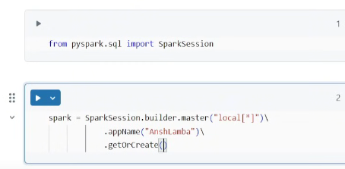Not required  
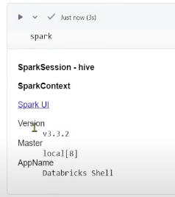Click on Spark UI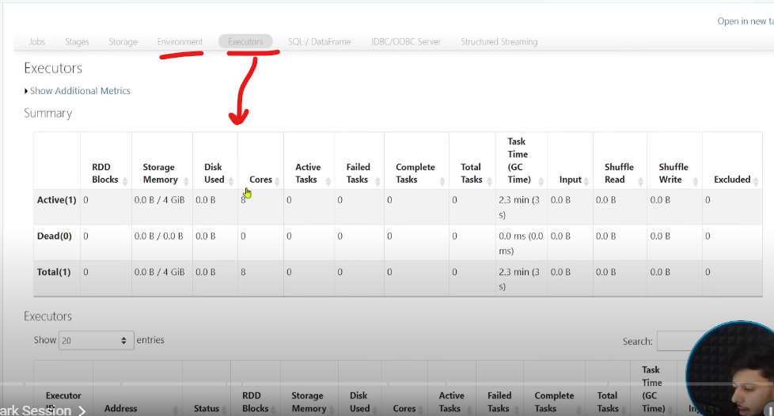  
You can play with spark session using spark.conf.set() but don’t have to create Spark Session in DB.  
DB removes all the overheads.  
  
  
  
  
  
  
**1. Scanning Optimisation 🡪 Partition Pruning**  
**Partition Pruning :** Don’t have to scan the entire data for a specified condition to avoid reading the entire data, so Partition Pruning helps optimising the partitions.  
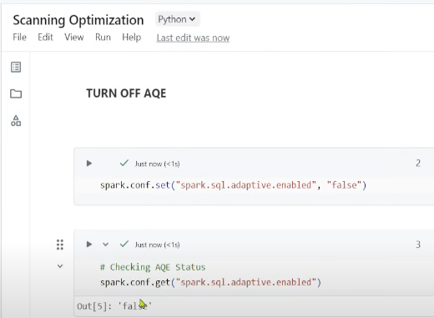 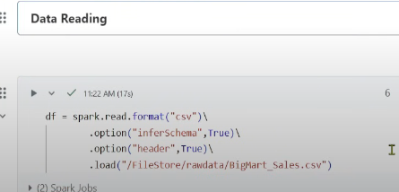  
Spark creates Logical partitions/small chunks on top of data (by default Block size is 128MB) 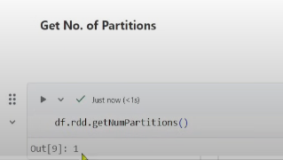Since we have peanut amount of data 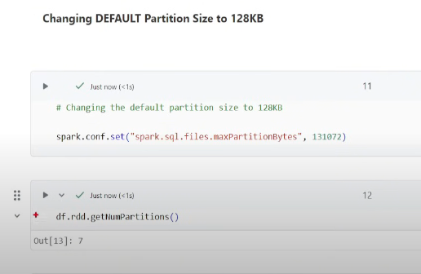Our file size is 850kb  
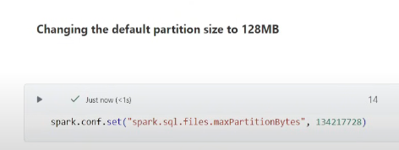 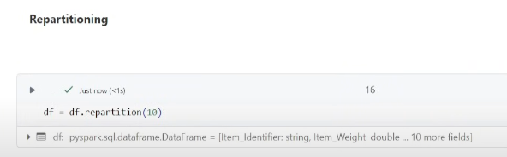 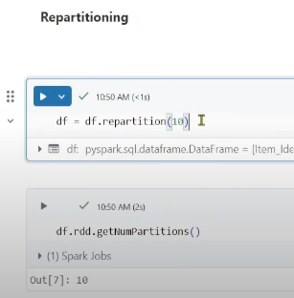  
Why partitions are required? 🡪 to apply parallelism, each cores in executor can perform the parallelism tasks.  
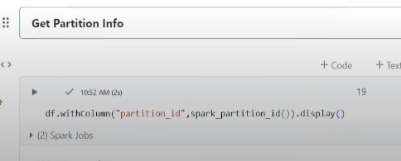  
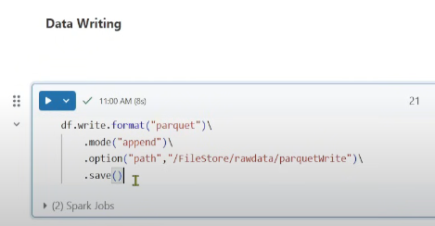 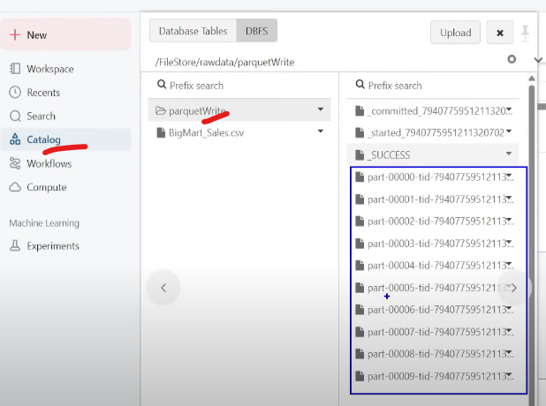 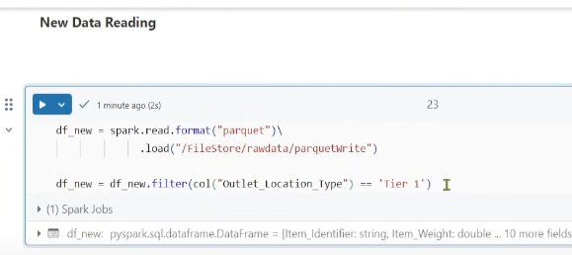  
Spark will read all the 10 files as it doesnot know where Tier1 data is present 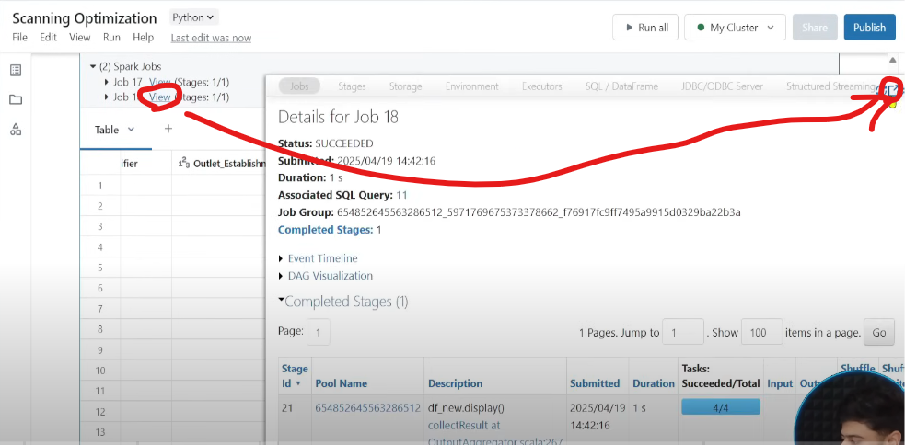  
Click on Jobs 🡪 Expand 🡪 SQL dataframe  
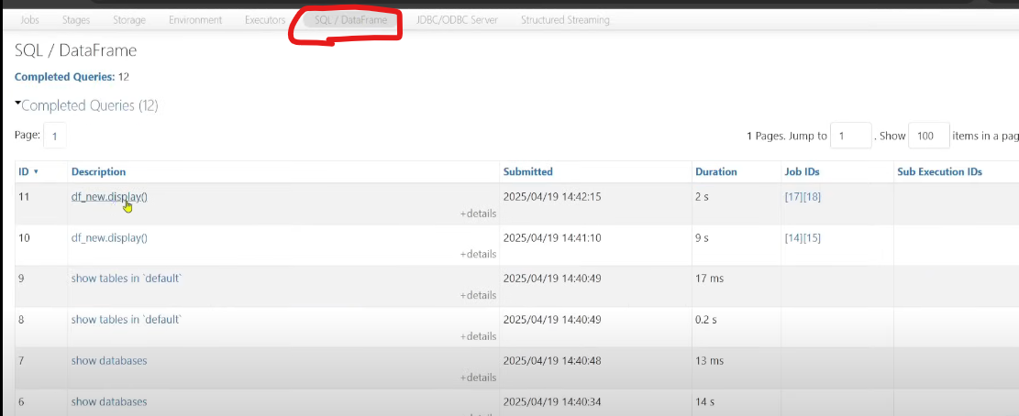 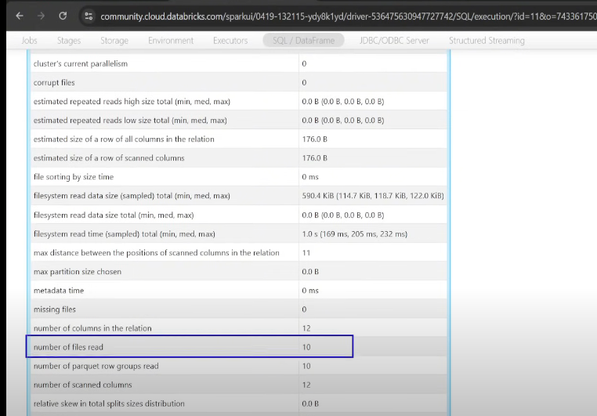   
Solution 🡪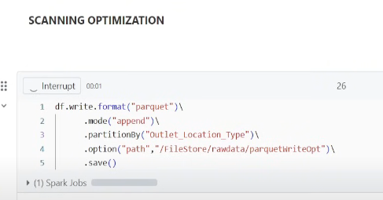 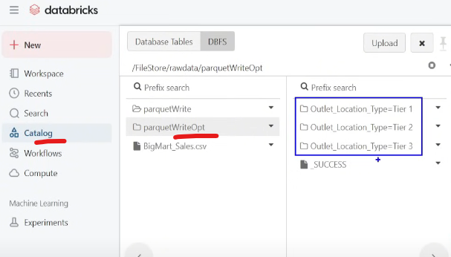  
Generally do Partitions on date columns🡪 best column🡪 year, month, date  
   
**2. Join Optimizations**  
Lets say we have 4 Executors, 1 Fact of size 1GB and 1 Dimension of 1 MB  
Join is a wide transformation, if AQE is disabled then Spark creates 200 Partitions , so Partiton1 will be having some data of fact and dimension joined with dimension key, similarly till P200, and all these partitions will be sent to Executors for execution.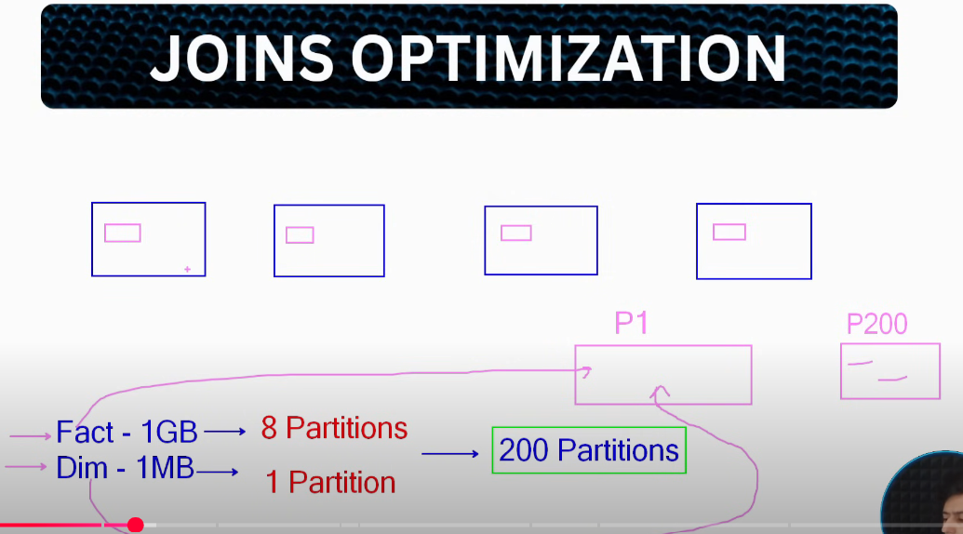  
To avoid Shuffling, we will do Broadcast join  
Driver will broadcast the smaller table to all the executors 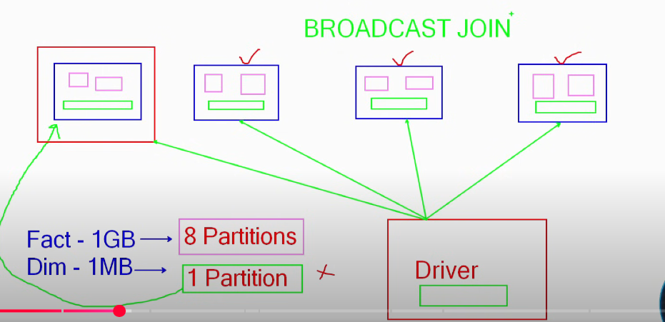 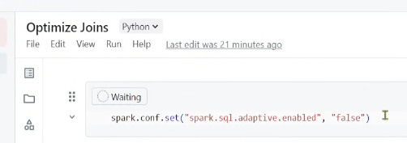 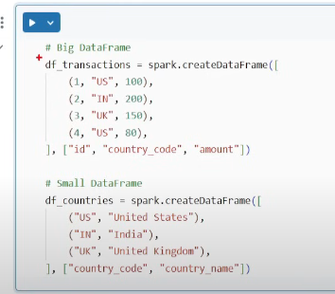 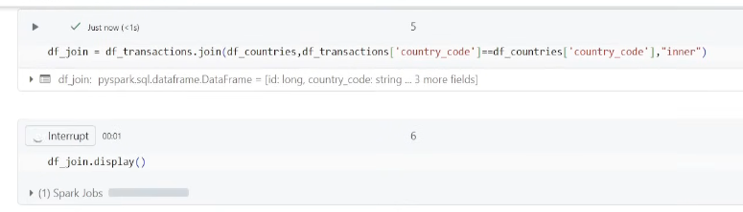 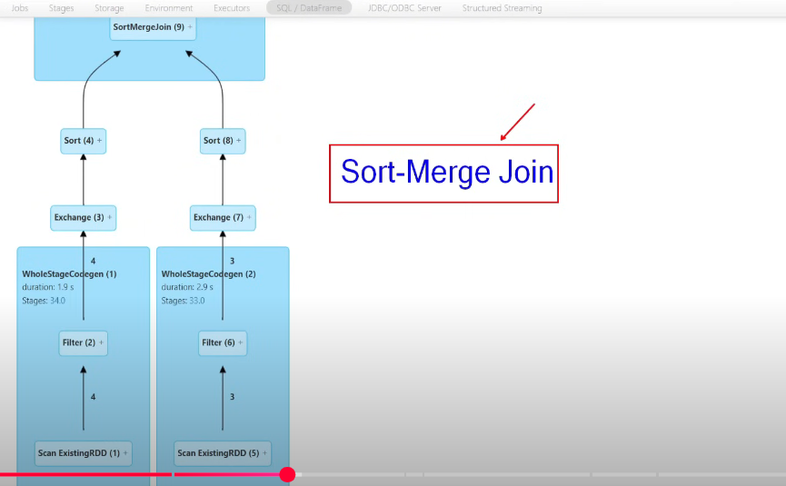  
Sort-Merge join has been performed, default join, sorting within 200 partitions & then join.  
Filter to remove nulls, Exchange is the step where shuffling happens 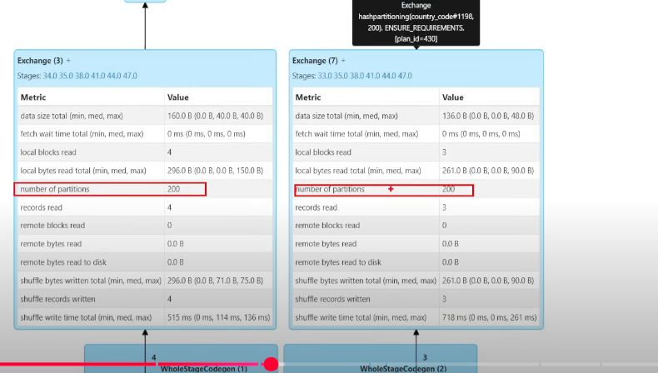  
200 partitons for 3-4 records, this is crazy  
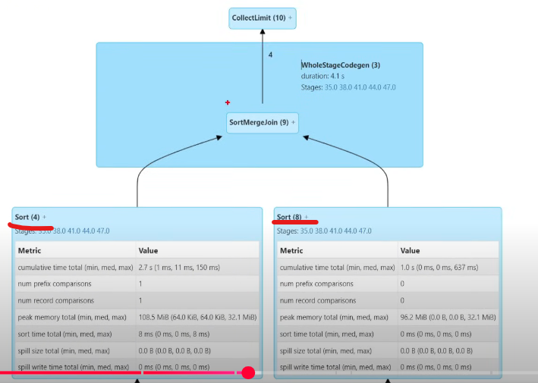  
Then it performs sorting and finally sort merge join  
 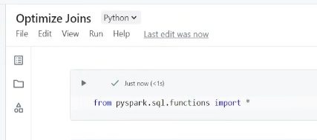 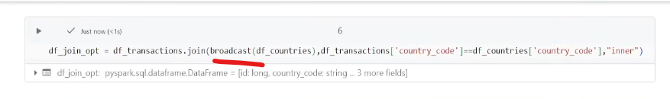 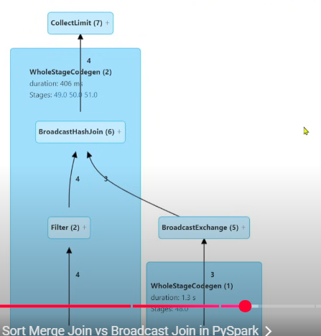 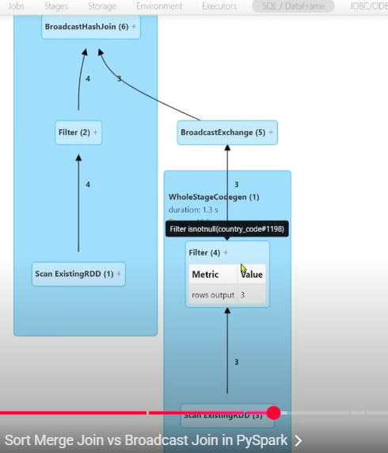  
  
**3. SQL Hints (Optimizations on Spark SQL)**  
 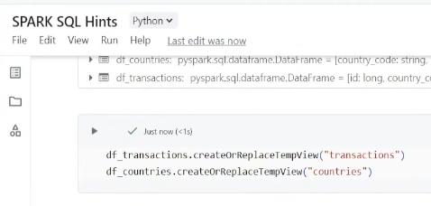 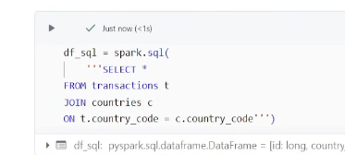  
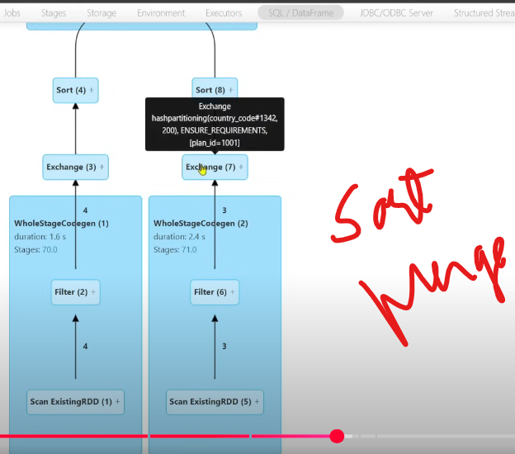 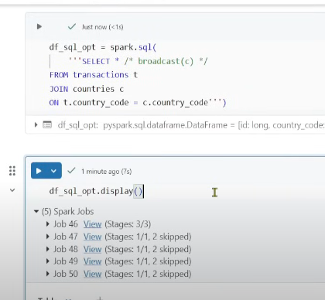Its just an advice to Spark, not a guarantee, it may consider may not.  
  
4. CACHING & PERSISTENCE  
Spark Pool Memory is 60% of overall memory, in which we have Storage memory & Executor memory. Executor memory is used to perform all the transformations, and it’s a short lived memory 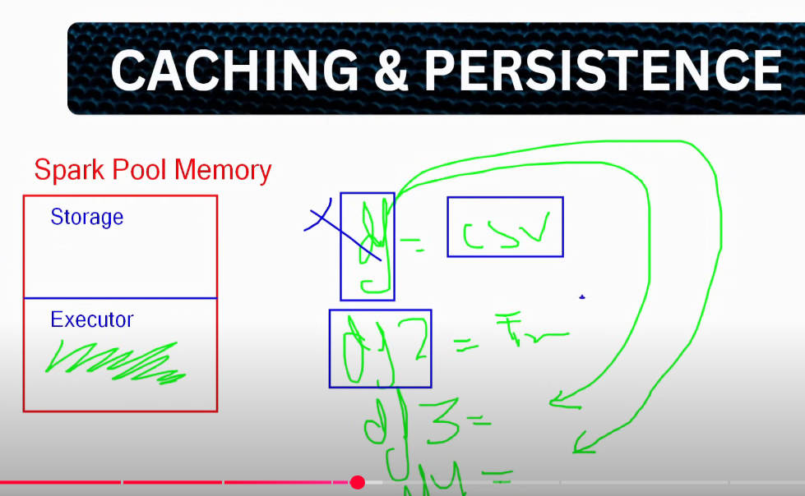  
Lets say in df we are reading a csv, in df2 we are doing some transformations, in df3 and df4 we are again using df, so every time it will be recalculated as df has not been saved anywhere, its happening in Executor memory which is a short lived memory. We need to store the data in Long Term memory i.e. Storage memory. 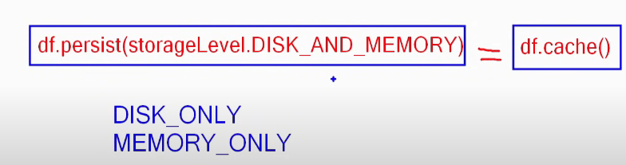 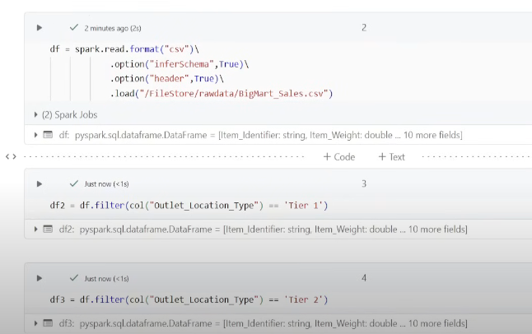  
df will be computed multiple times 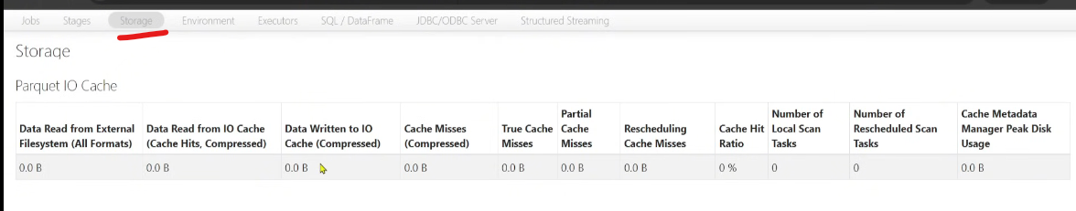   
Now let’s cache it  
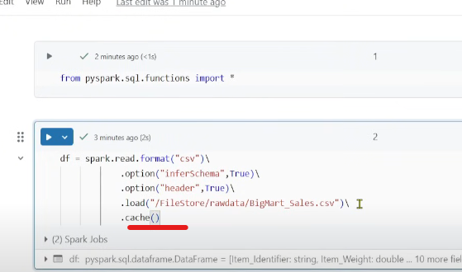 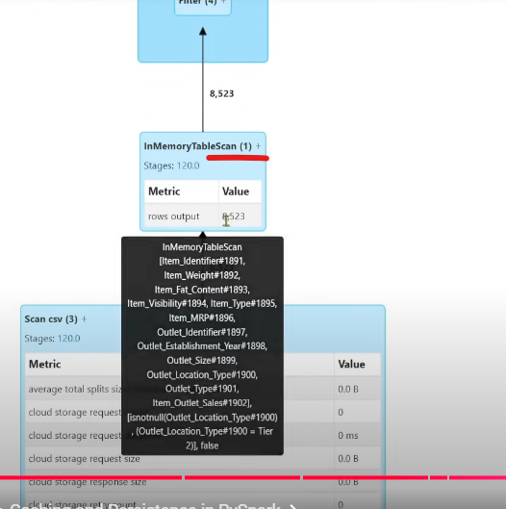 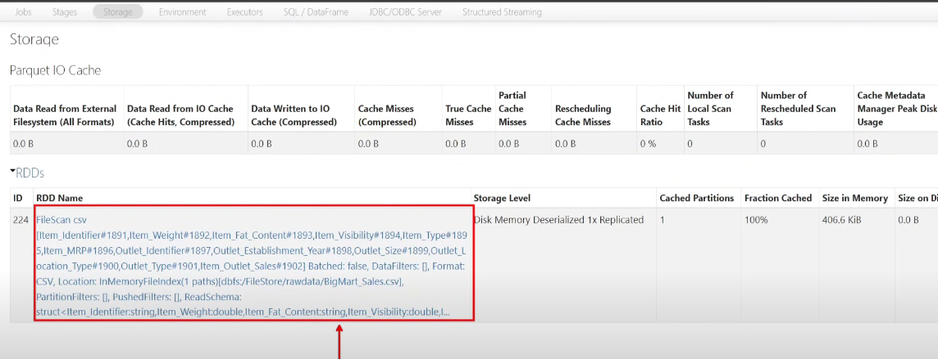  
To finally remove the cached data  
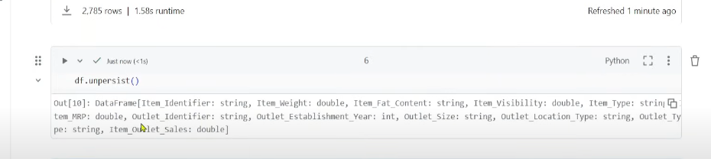  
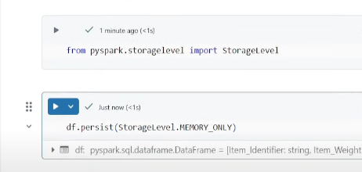  
  
**5. DYNAMIC RESOURCE ALLOCATION**   
Now auto enabled  
  
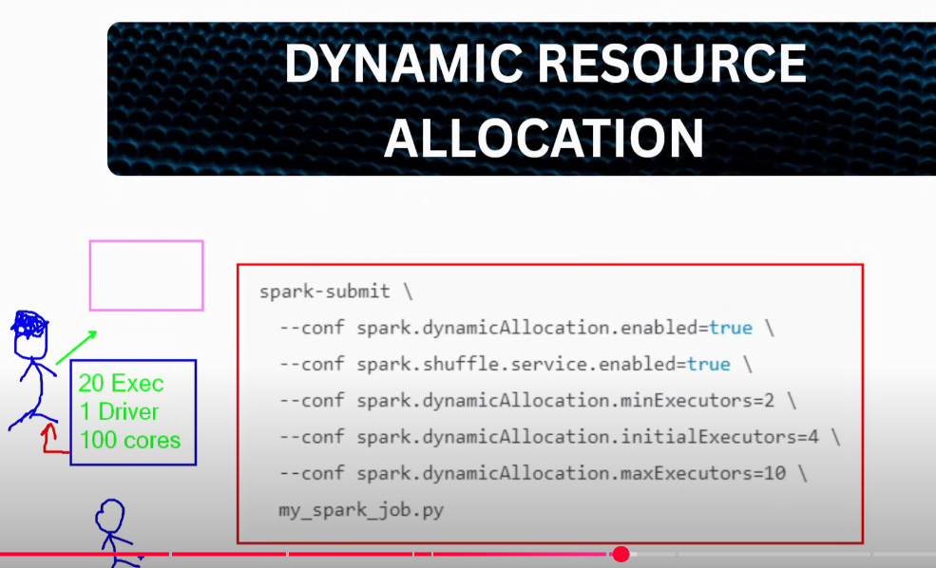

Requesting resources from Cluster Manager, all these resources will be locked with you till you kill the application even if you are not utilising all the resources.  
Now there is another developer who cant submit any application because those resources are already in use.  
Best solution is **DYNAMIC RESOURCE ALLOCATION,** resources will not be locked, if executors are in idle state, those executors will be released, Its like Spark Pool in Synapse, DB and Fabric.  
  
**6. AQE (Adaptive Query Execution)**  
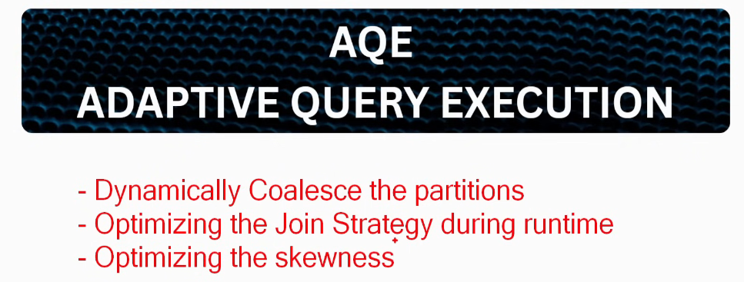Dynamically coalesce the number of partitions from 200 to required number  
Optimizes the Joins whether a Broadcast or a Sort Merge   
Optimizes the skewness 🡪 when a particular partition is very big then it breaks down into smaller partitions  
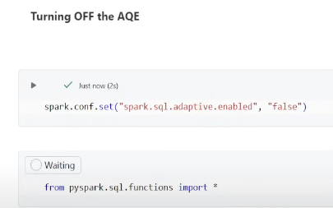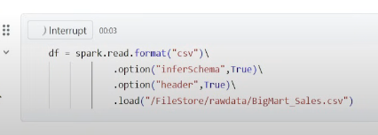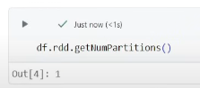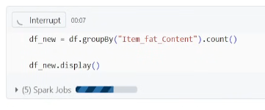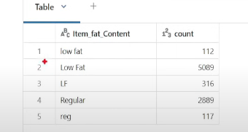So there are 5 partitions, and rest 195 partitions will be empty, wating all these resources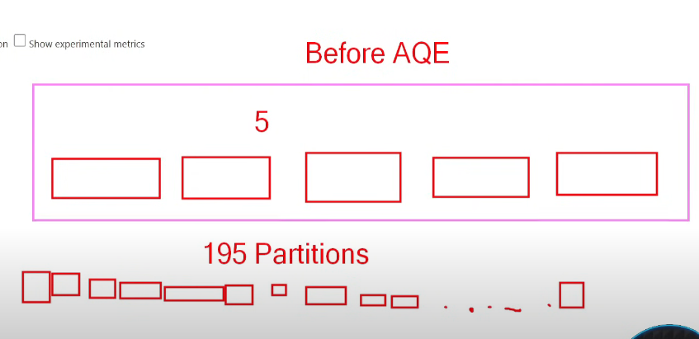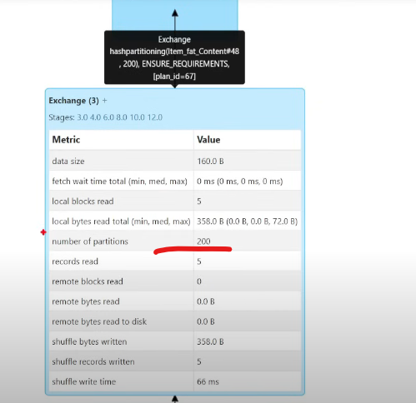  
Enabling AQE and rerun the code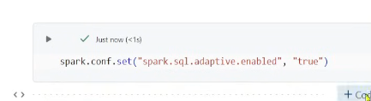  
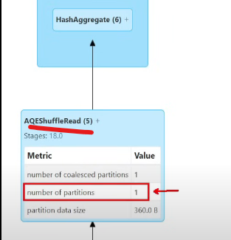from 200 partitions to 1 partition, AQE firstly removes all the 195 empty partitions and then coalesces the partitions from 5 to 1.  
**7. DYNAMIC PARTITION PRUNING**  
Advanced version of Partiton Pruning  
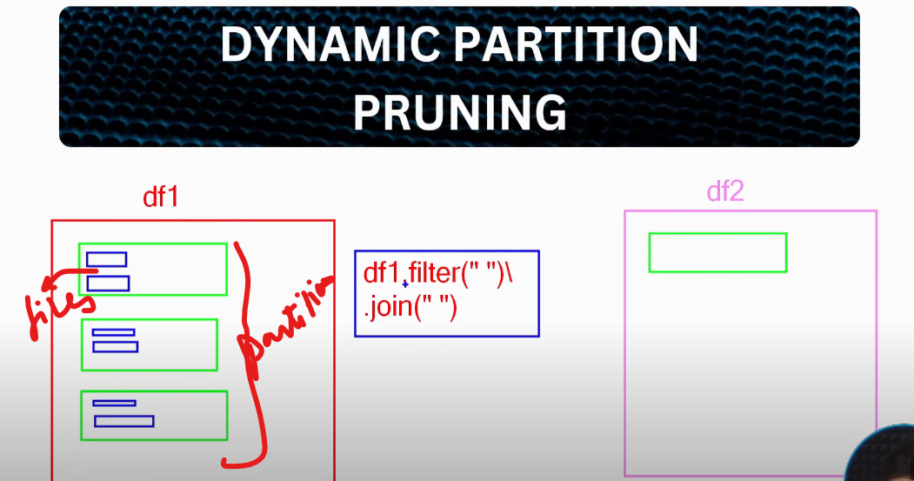   
Lets say df1 has 3 partitions & df2 has 1, if I want to join df1 and df2 by applying filter on df1 🡪 this is basically Partition Pruning  
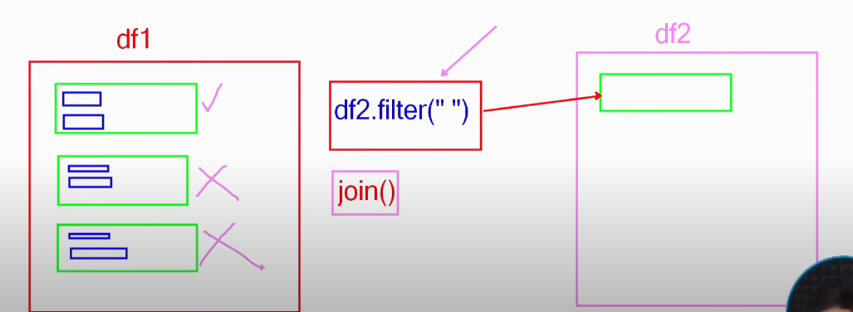  
Now lets say we are joining df1 and df2, by applying filter on df2, so it should read all the partitions of df1 right?But lets say based on the filter condition of df2 the matched records are found only in one partition of df1, then it don’t have to read the other partitions, this is Dynamic Partition Pruning.  
DPP pass the filter of df2 to df1 during runtime, simply broadcast the value of df2 to df1.  
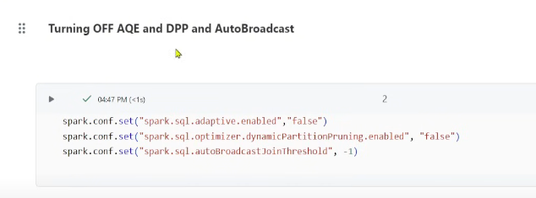 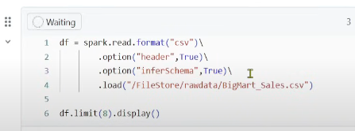 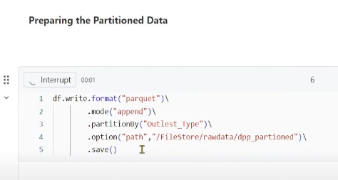 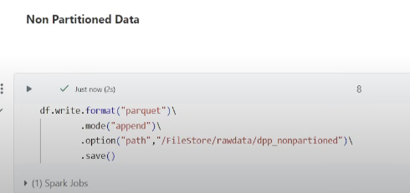 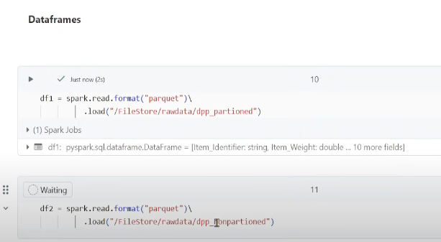 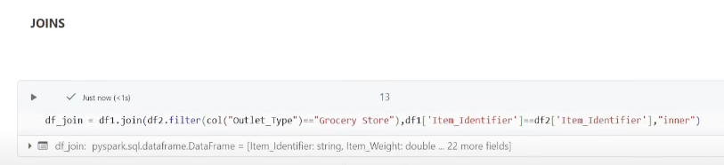   
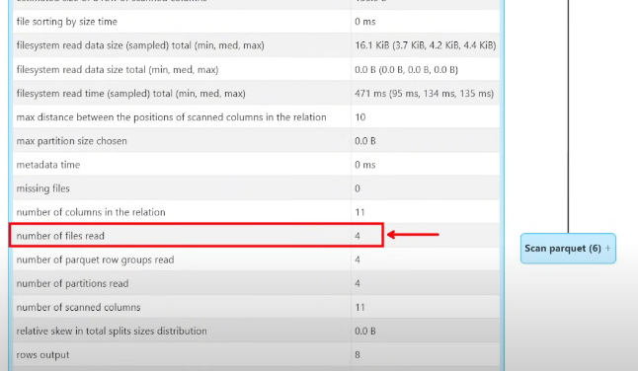  
Now enable DPP  
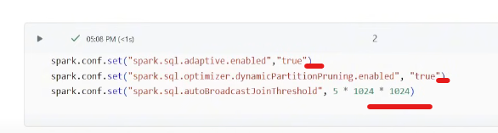  
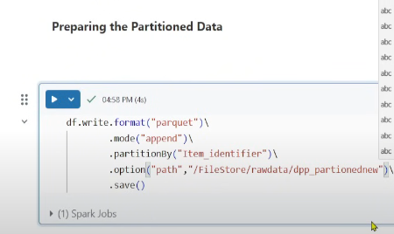 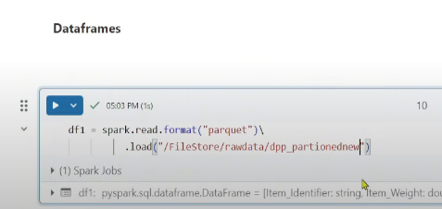 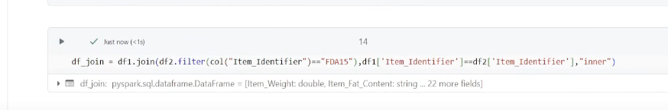 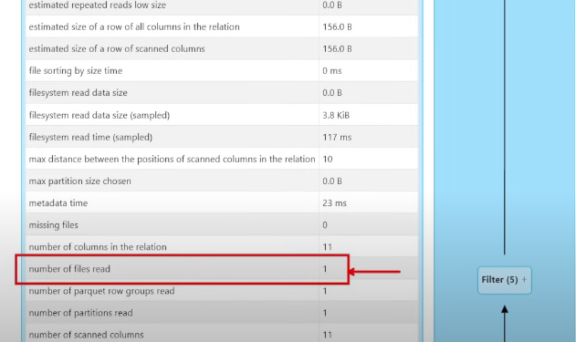

**8. BROADCAST VARIABLE**  
Lets say if you are having a dictionary inside a UDF (like a mapping), then we pass the variable to all the Executors, but doing it over & over again causes a n/w overhead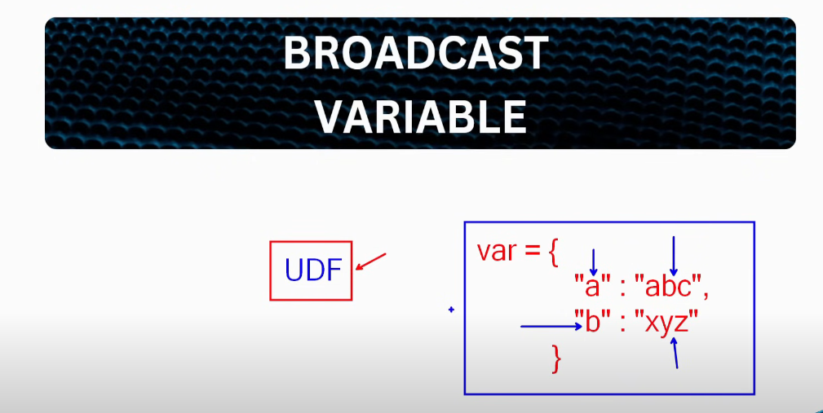Simply broadcast the variable to all the executors, so that everytime this variable is needed, it can be retreived from the memory  
 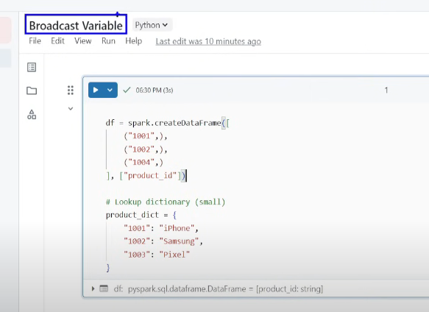  
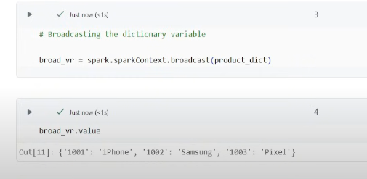 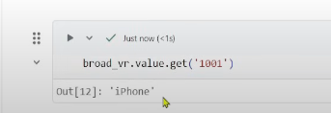 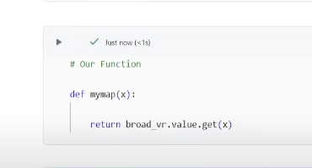  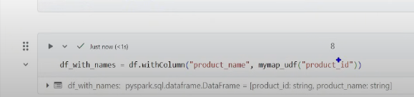 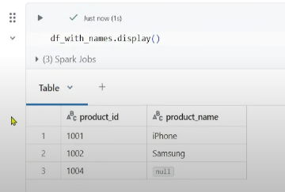

**9. SALTING**  
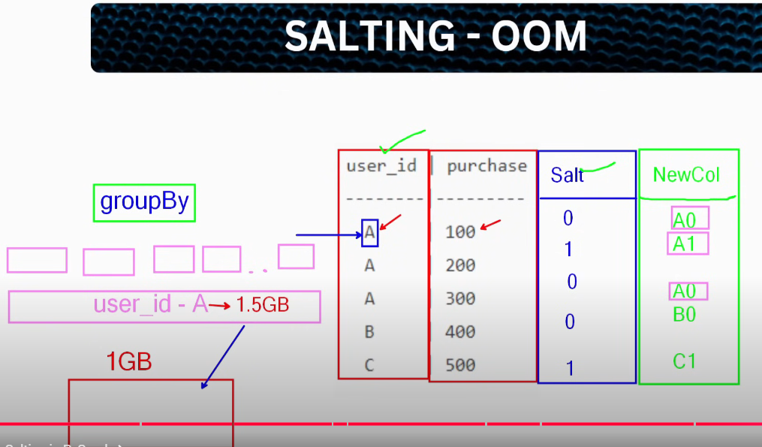  
Partition of A is very very huge, lets say 1.5GB whereas Executor has 1GB memory, partition will not memory🡪 OOM  
Introduce a new column with random numbers, break big partition into smaller partitions 